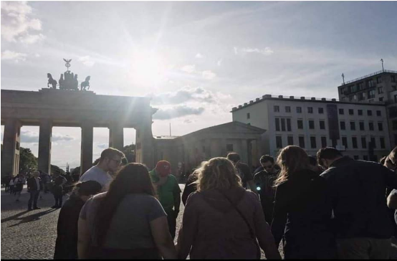

JTC X-Change Board of Directors, I hope you are doing well!
My name is Bianca Sancimino and I am so excited to share this with you! In 2017 I had the amazing opportunity to Join Dallas Christian College on a Missions trip to serve alongside European Initiative. We worked with refugees, a trafficking ministry, did street evangelism, and served in a church. I also had the opportunity to preach, sing and lead worship, perform in a drama, serve in a few coffee shop ministries, meet new people, do school outreaches, a university outreach, and help with renovations. God did amazing things here; it was such a blessing to be apart of! I am sharing with you that have the incredible opportunity to do this again, because I was invited back to serve with EI’s internship program in Berlin and Europe for the month of June and I am so very excited!
This is an intense missionary training internship program where I will be spending a portion of the month in Berlin and the last portion in another part of Europe that will be announced once I am there in Berlin. Leaders of European Initiative will equip us in ministering, street evangelizing and evangelizing through fine arts, providing aid to an impoverished Eastern European country, and teaching and loving on those who have not experienced the love of Christ.
Europe is a lost continent and when I was there, I personally have never met so many individuals who have never heard of, or refuse to believe in the name of Jesus Christ; it was heartbreaking. What I learned after being over there, is that the country and the continent is lacking love and empathy, because those who turned their lives to Jesus Christ were in AWE that someone on this planet could love them so much. I can not wait to go back and be apart of this once more. I felt like I was not finished over there in Europe and sure enough, God has called me back.
This trip is a huge undertaking that I cannot accomplish alone, so I would like to share with you a few needs and present to you an opportunity to participate with myself and EI. First and foremost is prayer; please join us in prayer, that the team and I can raise adequate funds, that we would be able to influence lives in Europe in Christ’s name, and that our hearts would be receptive to the lessons that God has in store for us there. The second need is finances – around $3500. As you can imagine, international missions work is not inexpensive, yet I believe that our work in June will be a valuable and worthy assistance to the Kingdom’s cause in Europe.
Would you consider making an investment in my Missions Trip for the sake of the work that we plan to do in Europe? If you choose to financially support myself and my team in Europe, please contact me to find out how at 2149079087 or biancasancimino@gmail.com.
Thank you for your consideration and for taking the time to read this and pray for myself and my team! God bless you!
Sincerely,
Bianca Sancimino

